Registration Missing Data Validation Attribute validation in UAT instance.

1. Application Description :

For the below to Mega Hex ID’s , the Application Description is Blank in Source , but the Missing Data is not displaying ‘Application Description’

SELECT SRC.NAME,SRC.PG_APPLICATION_DESCRIPTION,SRC.cdctype

FROM png_mdsdb.pg_mega_pgb_application_rita_final SRC

LEFT JOIN png_mdwdb.d_rita_application_c TRGT ON SRC.NAME=TRGT.row_id AND SRC.sourceinstance=TRGT.source_id

Where SRC.NAME IN ('E46FE914536847C1','094E0A2D57063749');

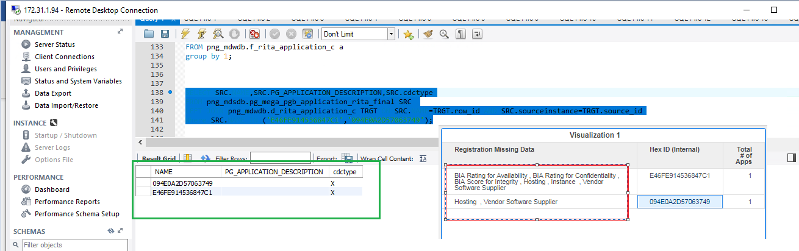

1. Data privacy: the condition is not satisfied.

Note: No PII Data is equivalent to ‘UNSPECIFIED’;

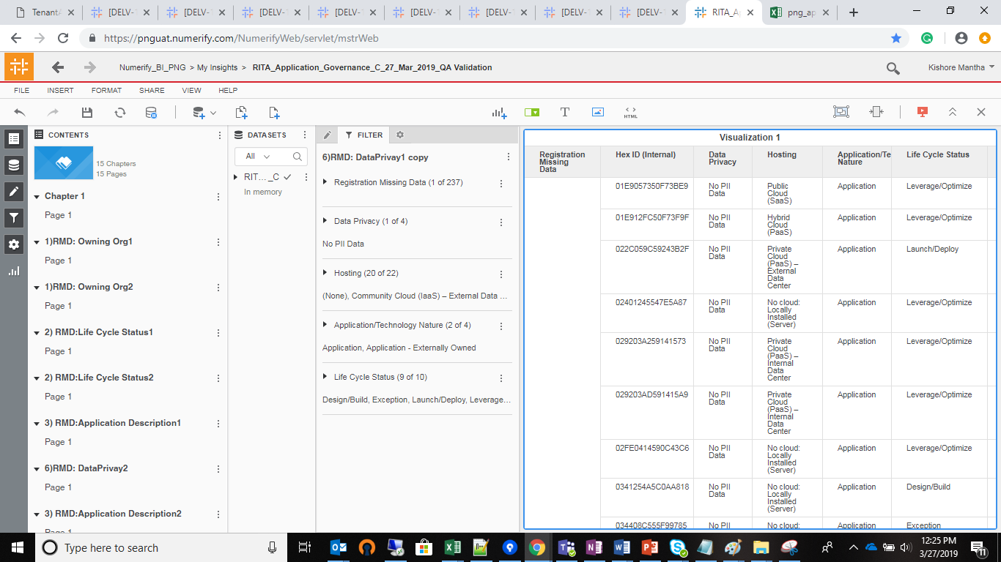

3) BIA Rating for Confidentiality:

The below case is missed , if the ‘BIA Rating for Confidentiality’ is Blank Or Not Performed’ and Life cycle status is ‘Discovery’ then Not a Blank , hence ‘BIA Rating for Confidentiality’ should not be part of ‘Registration Missing Data’

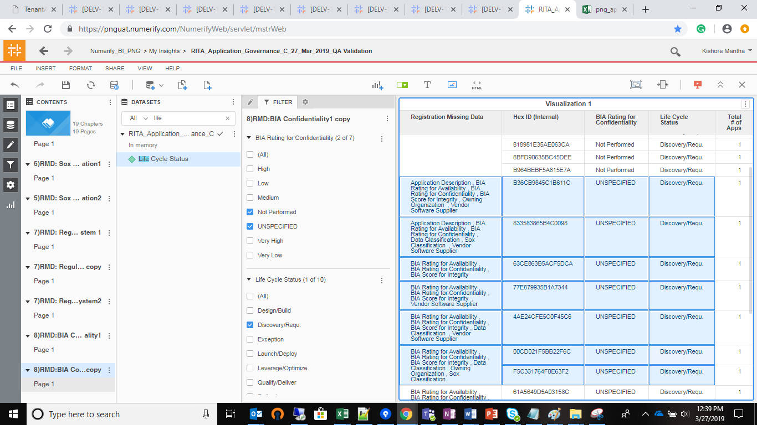

4) the Same issues for the ‘BIA Rating for Availability’:

